4203201
SOIL MECHANICS
2ND MIDTERMN EXAM
December 16th, 2013

Name & Surname:
Q.1 | Q.2 | Q.3 | Q.4 | Q.5 | TOTAL
Number:
Group:

- a) Which laboratory tests are used to determine the shear strength parameters of soils? Which tests can be performed to determine shear strength parameters of a sandy soil? Explain briefly.

b) Define the terms of normally consolidated clay and overconsolidated clay.

- The groundwater level shown in the below soil profile is planned to be lowered by 2.5 m.
- Compute the primary consolidation settlement that will take place due to lowering of ground water table by 2.5m.
- Compute the time required for 90% consolidation to take place in the field. (Sand layer above ground water level will be considered dry).
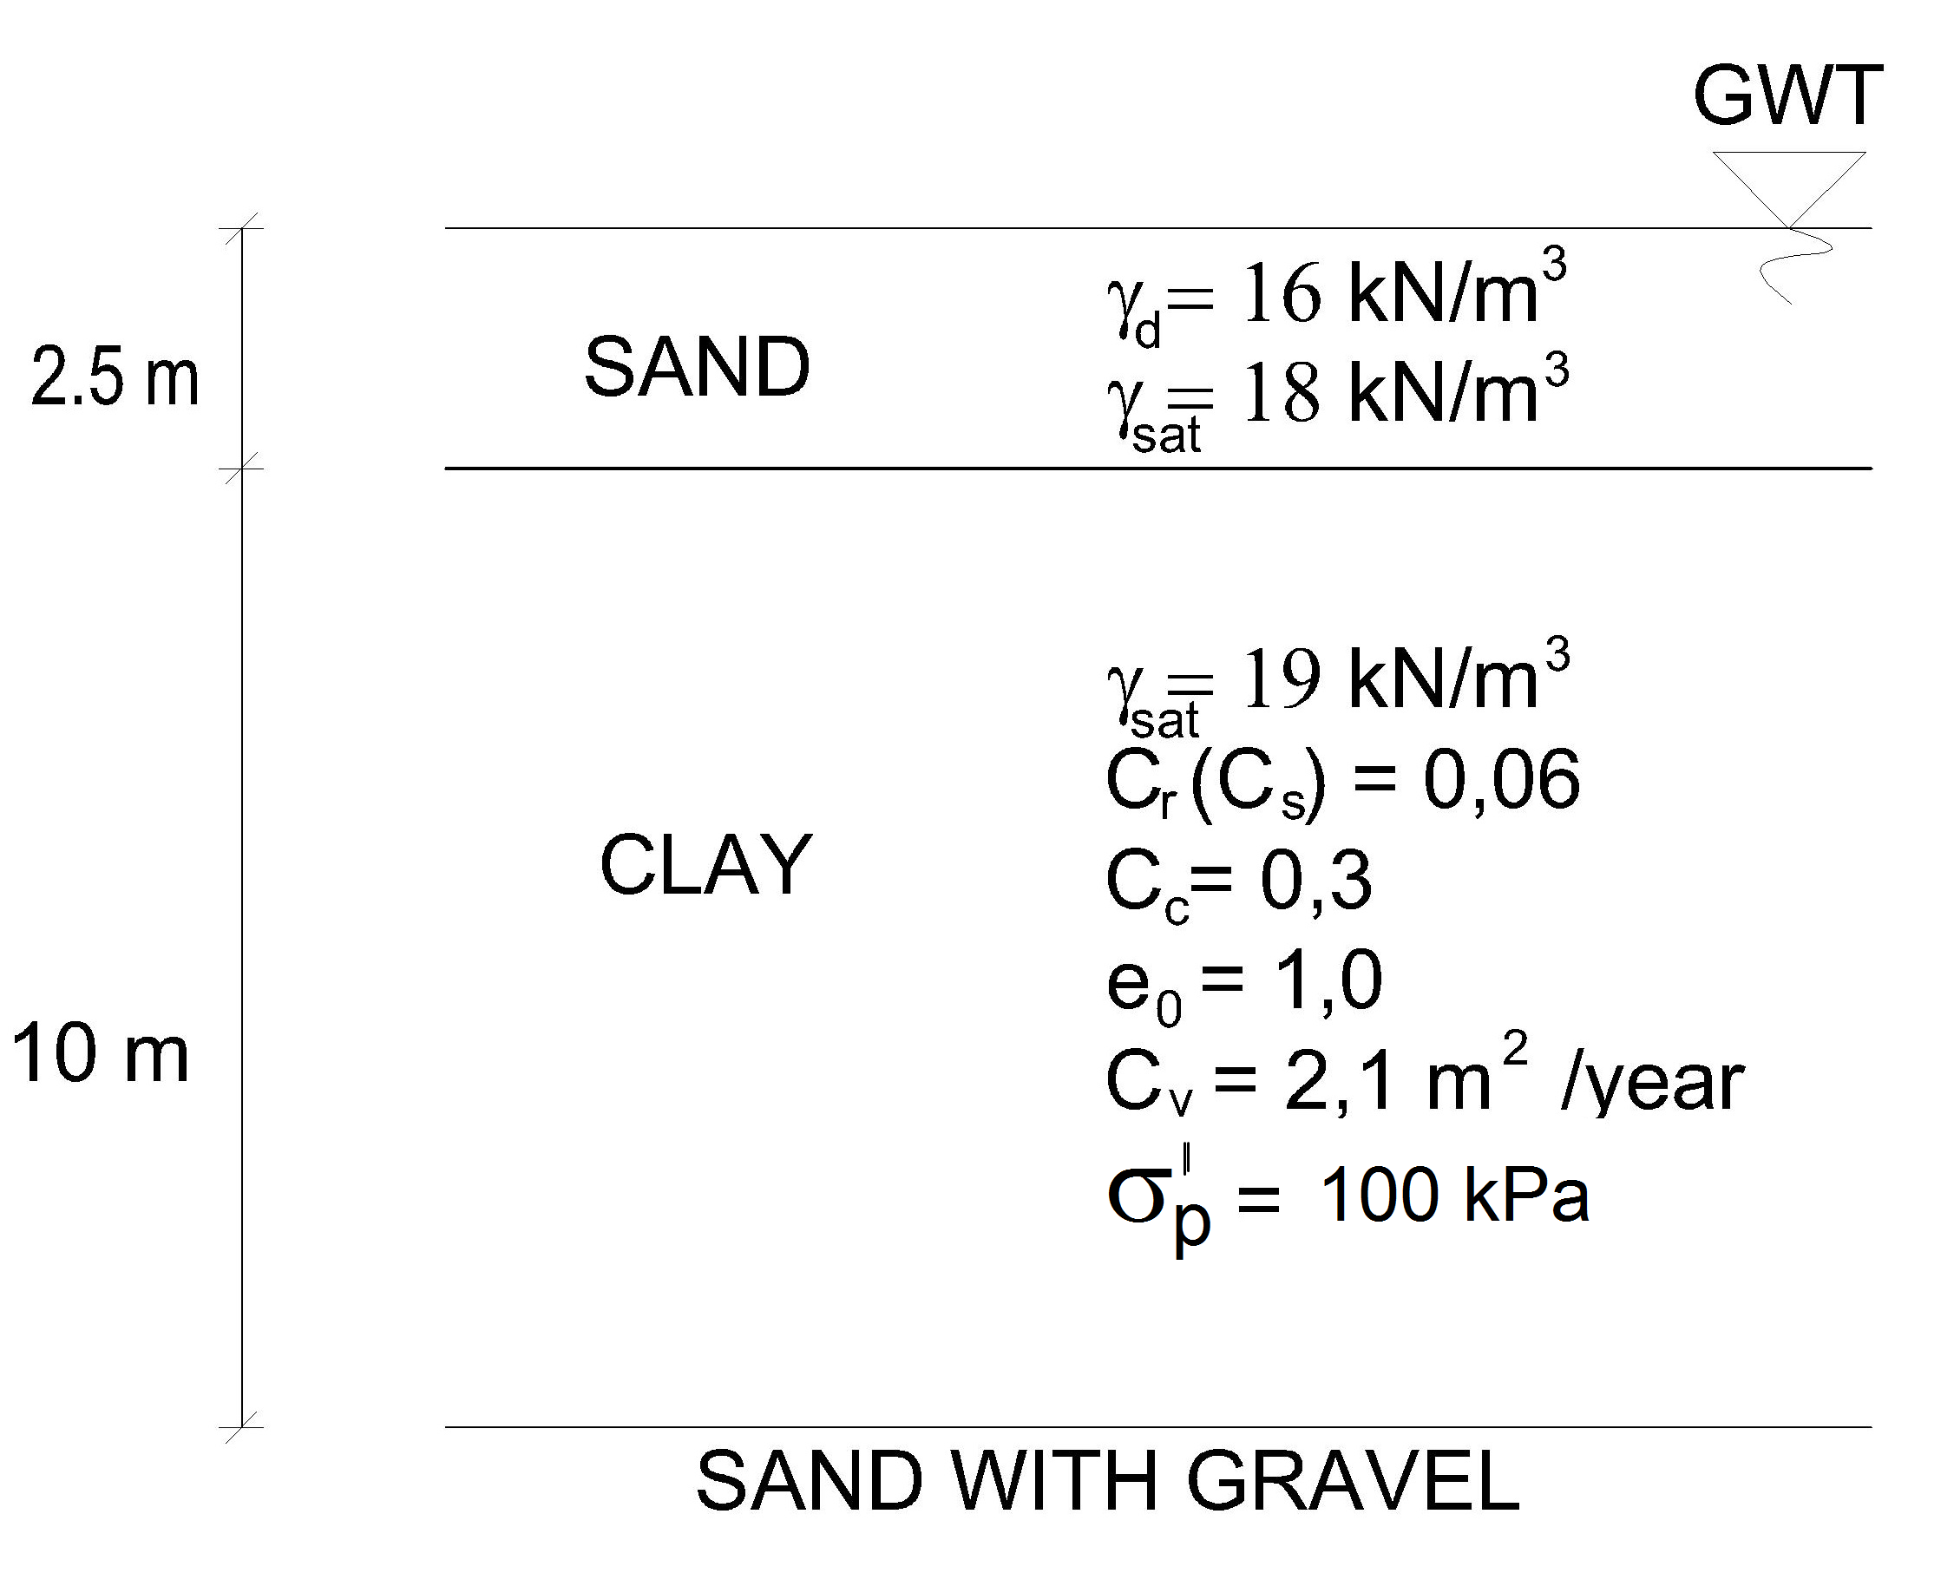
U (%) | 10 | 20 | 30 | 40 | 50 | 60 | 70 | 80 | 90
T_{v} | 0.008 | 0.031 | 0.071 | 0.126 | 0.197 | 0.287 | 0.403 | 0.567 | 0.848

- A 15m x 20m raft foundation will be constructed over the soil profile shown in the below figure. The oedometer test results performed on the clay sample recovered from the middle of the normally consolidated clay layer are given in the below table. Compute the primary consolidation settlement that will take place underneath the center of the foundation.
(Use simplifed method to determine the vertical stress increase due to foundation loading)

Pressure (kPa) | 0 | 25 | 50 | 100 | 200 | 400 | 800 | 400 | 200
Void ratio | 1.132 | 1.125 | 1.112 | 1.080 | 1.010 | 0.940 | 0.870 | 0.883 | 0.896

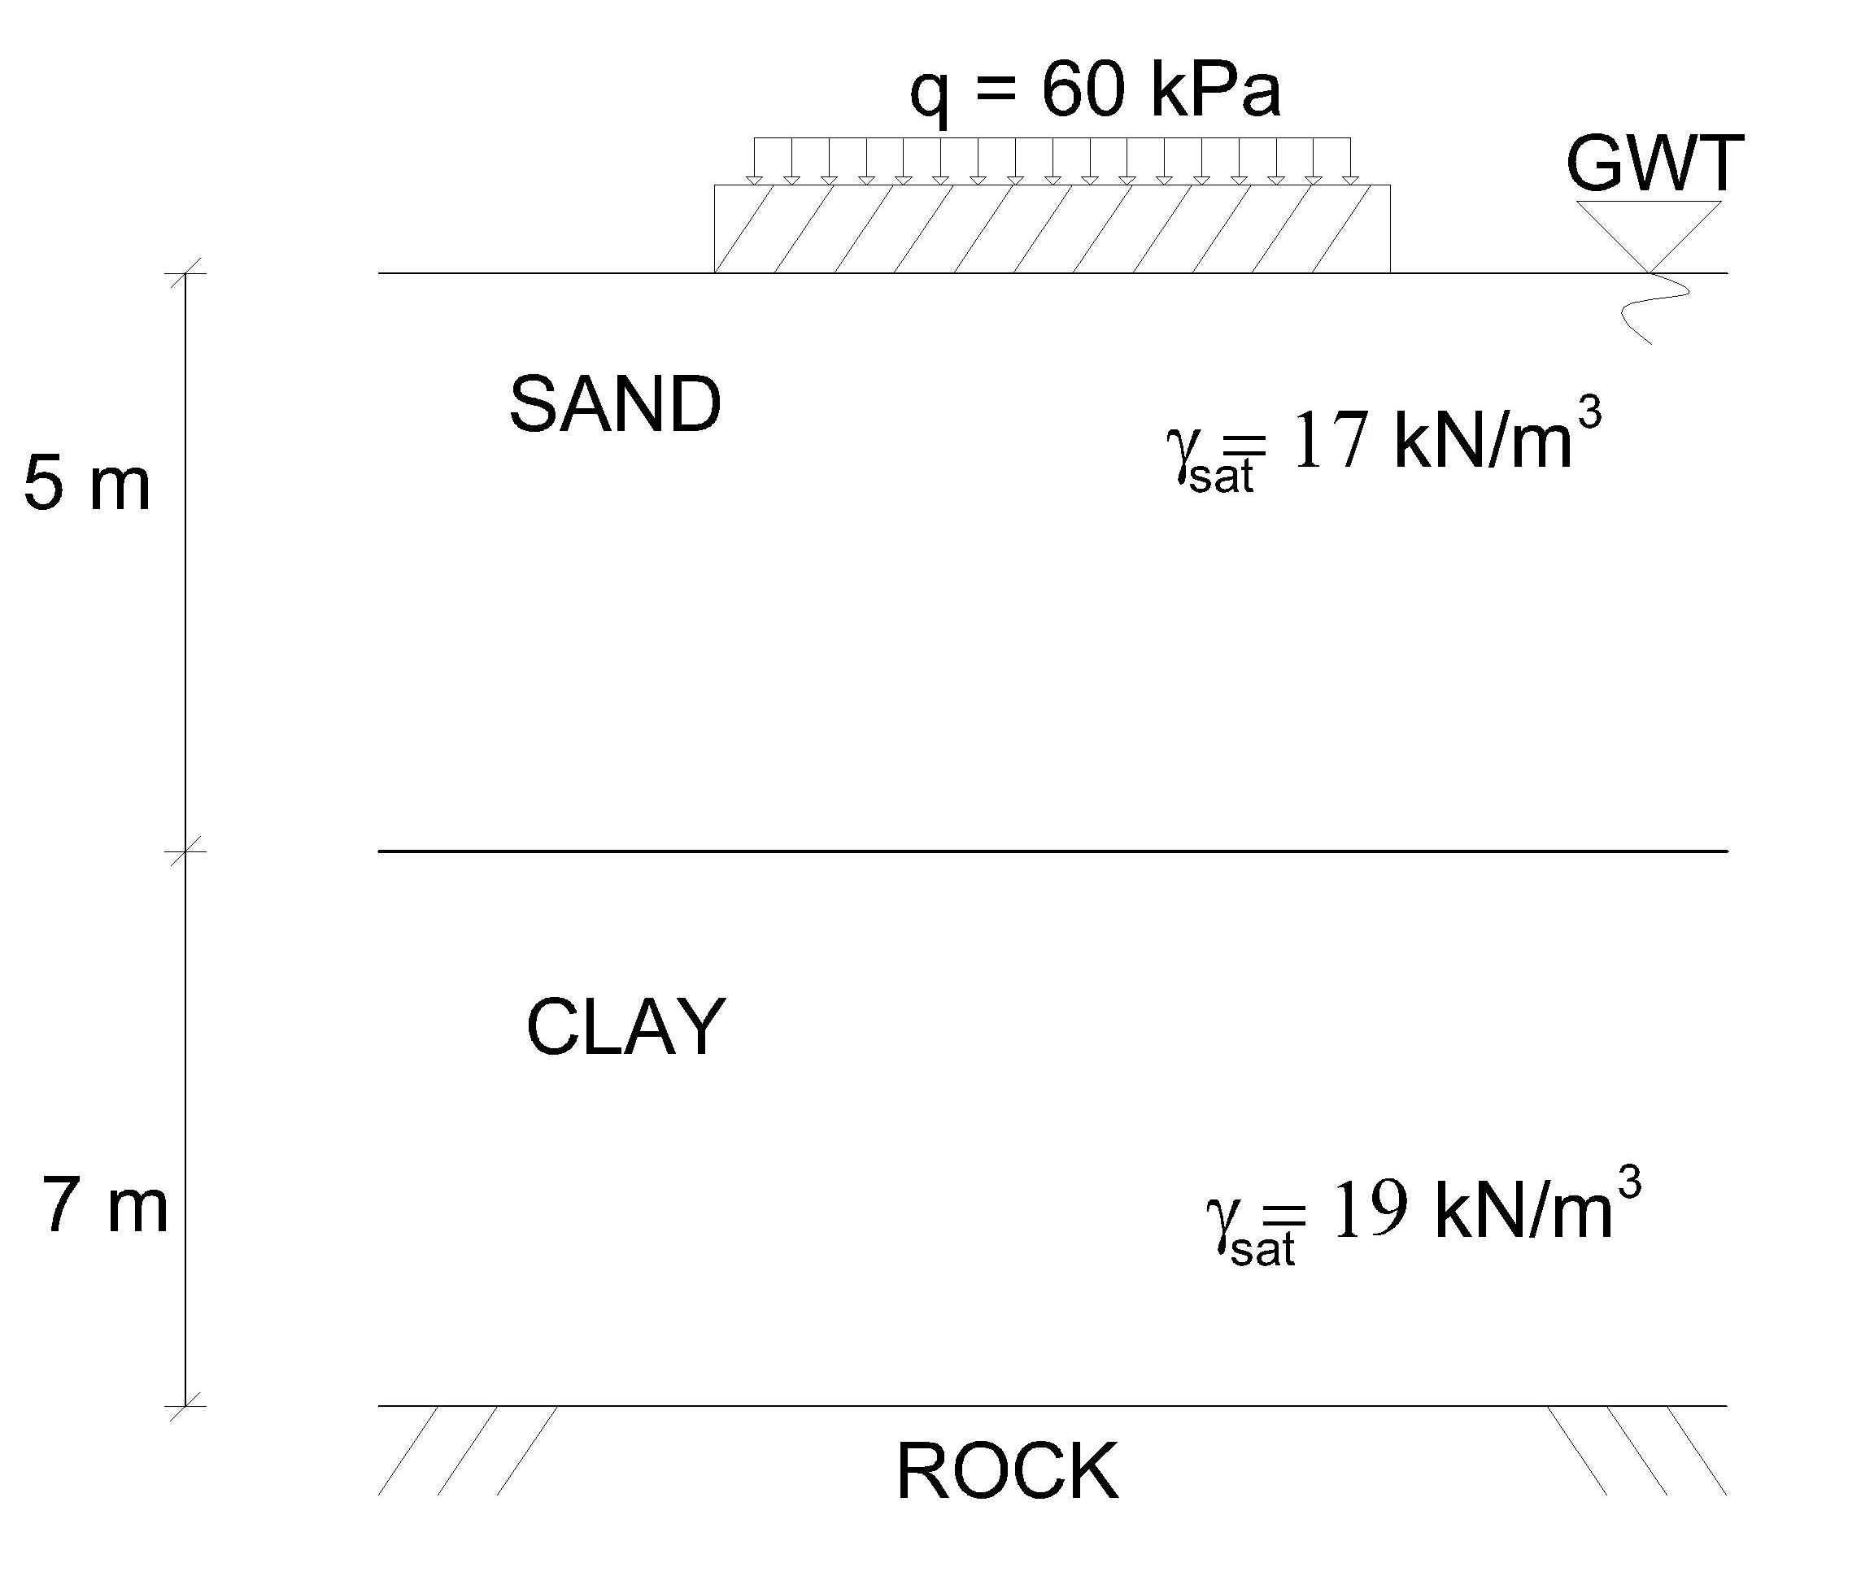

- A series of consolidated- drained (CD) tests were carried out on undisturbed clay samples consolidated under a pressure of 100 kPa in the field. The test results are as follows:

Test | 1 | 2
σʹ_{3f} (kPa) | 100 | 174
σʹ_{1f} - σʹ_{3f} (kPa) | 231 | 329

a) Plot the Mohr Circle and failure envelope for the experiment.
b) Determine the effective shear strength parameters of the clay.
c) State if the clay is a normally consolidated clay or an overconsolidated clay.

- An unconfined compressive strength test was performed on a clay sample recovered from the middle of the clay layer shown in the below soil profile. If the unconfined compressive strength (q_{u}) of the clay sample was obtained to be 120kPa:

- Plot the Mohr circle and failure envelope for the experiment.
- Determine the principal stress difference that caused failure during the test.
- Compute the undrained shear strength parameters for the clay sample.
- Compute the angle that failure plane makes with respect to horizontal.
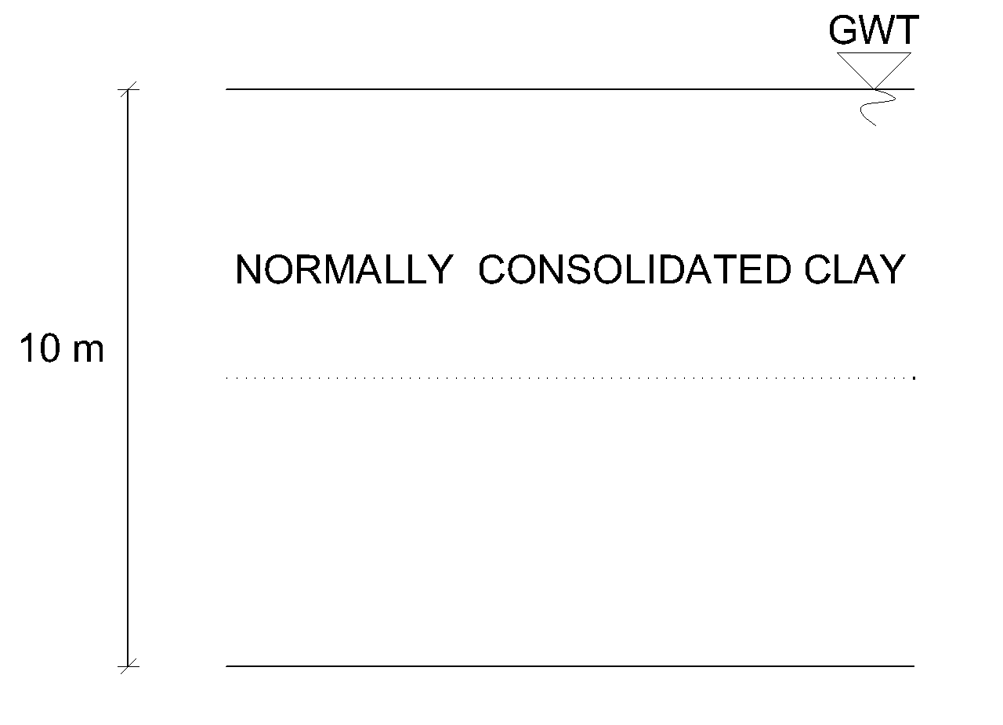

Duration is 90 minutes.
Good luck.

